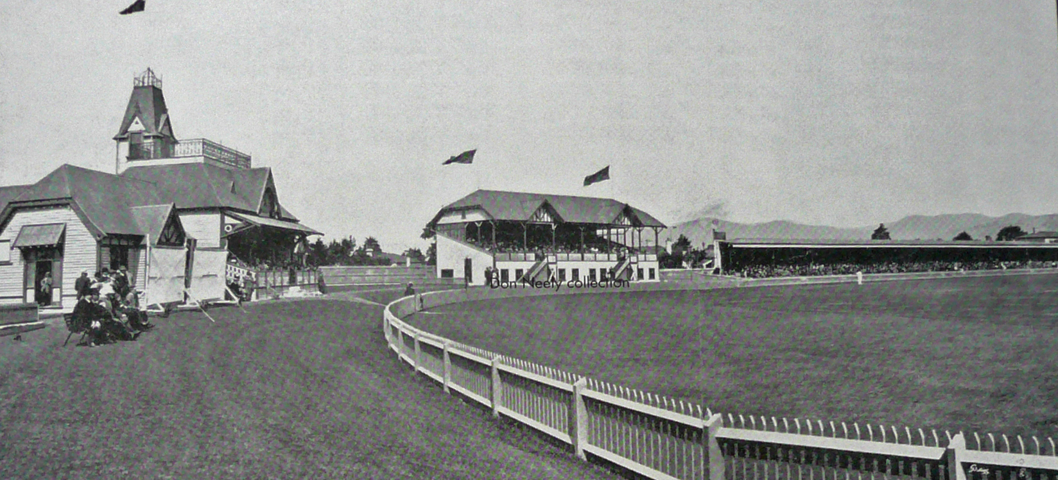

**No 1 (Members stand), No2 and No 3 (East) stands Canterbury v Otago 22 March 1913**

Otago 110 & 81. Canterbury 242. Canterbury won by an innings and 51 runs